Strathclyde Cloud Transformation Programme

Benefits Management Strategy

Introduction
The purpose of this document is to outline the Strathclyde Cloud Programme’s approach to benefits management. It accompanies the programme’s Governance Structure, which outlines how the programme will be managed overall, and is based on the Managing Successful Programmes (MSP®) methodology, which places a benefits-led approach at the core of its methodology.
The key advantage of a benefits-led approach is that it ensures the programme Steering Group maintain a clear focus on the benefits and objectives, as described in the business case approved by the Executive Team, throughout its governance.
Benefits management practice extends from the identification of benefits during the development of the business case through to their realisation during and beyond the formal closure of the programme.

Definitions
MSP provides the following definitions of a programme, a benefit and benefits management:
- A Programme is a temporary flexible organisation structure created to co-ordinate, direct and oversee the implementation of a set of related projects and activities in order to deliver outcomes and benefits related to an organisation’s strategic objectives. A programme is likely to have a life that spans several years.
- A benefit is a measurable improvement resulting from an outcome perceived as an advantage by one or more stakeholders, and which contributes towards one or more organisational objectives.
- Benefits management is the identification, definition, tracking, realisation and optimisation of benefits within and beyond a programme.

Principles
The benefits management strategy is based on the following underlying principles
- Start with the end in mind.
  - Programmes should be benefits-led, rather than activity-led, with the scope of activity in the programme plan determined by the benefits described in the Benefits Realisation Map taken from the approved business case (see section 5.3).
- Align benefits with strategy.
  - End benefits (see section 3) should, where possible, align with KPIs described in the university strategy. This enables a clear line of sight to be drawn from each individual project to the end benefit and, in turn, to the organisational or strategic objectives that the programme supports.

- Integrate with performance management.
  - Benefits should be incorporated into systems or services delivered as outcomes of the programme and reflected in their service definitions and performance targets.
- Integrate with successful delivery methods.
  - Benefits management does not specify a method of delivery for realising benefits so should be integrated into existing approaches to monitoring BAU, project and programme delivery.
- Focus on tracking high level benefits.
  - Benefits management should not create an industry, its purpose is to evidence progress towards programme targets and create management information that enables senior staff to make strategic decisions about the shape and continuity of the outcomes being delivered. As such, it should concentrate effort on tracking significant benefits that indicate the overall success of the programme.
  - Emergent benefits (see section 3) tracking may be used to highlight and celebrate successes within individual projects where additional value can be identified.

Summary of Key Benefits to be Delivered by the Programme
In July 2020, the Executive Team approved the Programme and the following high-level benefits:
- At least 70% of staff embedding MS Teams into their daily working practices.
- At least 70% of students adopting MS Teams to support their studies.
- Reduced carbon emissions of approximately 1,082 kgCO2e per year by transferring the emissions to Microsoft data centres, which are currently carbon neutral and will be carbon negative by 2030.
- Cost-savings –
  - Up to £117K per year, depending on decisions around the rationalisation of existing tools.
  - Up to £339K one-off savings in IT infrastructure costs through the decommissioning of on-premises servers (not including electricity savings).
- Reduced risk of security events evidenced by increasing Strathclyde’s Microsoft security score to be above the industry average.
The Programme’s Benefits Realisation Map (see section 5.3) provides further information on the objectives and benefits contained within the Business Case.

Benefits Eligibility
Benefits should only be claimed by a programme if they are:
- Describable – a clear definition avoids any ambiguity about the nature of each benefit.
- Observable – a baseline must be established, which is then used as a comparison against future-state performance.
- Measurable – a method must be established to measure the benefit, preferably integrated into existing monitoring methods.
- Attributable – a benefit can only be claimed if it is the direct result of actions taken by the programme and should not be claimed by other programmes or projects.

Benefit Types
There are four types of benefit:
- End benefits – the high-level key benefits identified in the approved business case that, when realised, will deliver the objectives of the programme.
- Intermediate benefits – positive improvements that can be used as indicators to give confidence that End Benefits will be achieved. Often realised in a relatively short timeframe.
- Emergent benefit – benefits that emerge during a programme, rather being identified at the start of the programme.
- Dis-benefit – a measurable, negative result of a change, as perceived by one or more stakeholders.

The Language of Benefits
Benefits should be defined using language that clearly describes the improvement, such as increased, decreased or reduced. The acronym MEDIC can be useful, e.g. Maintain, Eliminate, Decrease, Increase, Create.
Benefits should not be defined using generic terms, such as better or improved.

Benefits Categories
Benefits in this Programme will be categorised as:
- Financial cashable – improvements where the benefits are ‘booked in’ to future budgets and resource plans, e.g. software licences costs that are no longer required due to a rationalisation of systems.
- Financial non-cashable – improvements that can have a financial value attributed to them, but are not ‘booked in’, e.g. staff time savings that do not lead to changes in headcount or the avoidance of future costs through the actions of the Programme.
- Non-financial – benefits that cannot have a financial value attributed to them, e.g. improvements in quality, such as increased customer satisfaction.

Benefit Category Decision Tree
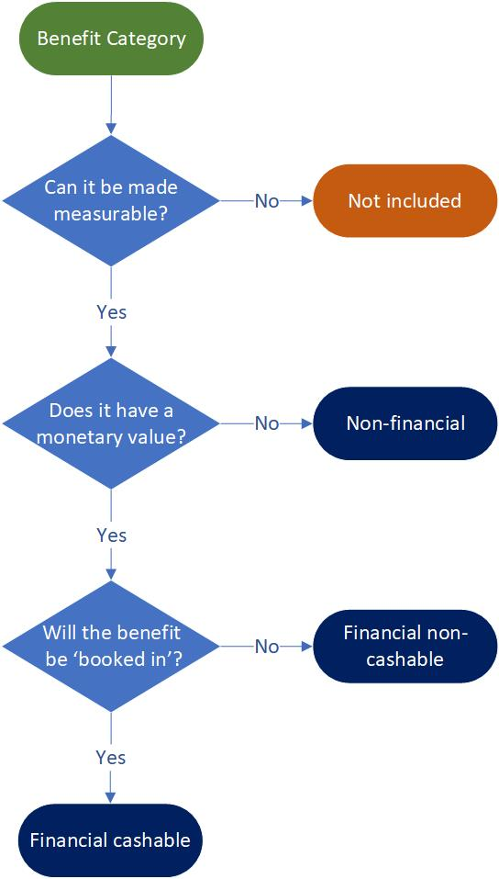

Identifying Benefits
The objectives and benefits of the programme are identified through consultation with stakeholders during the development of the business case. The outcomes of this consultation process are captured in a Benefits Realisation Map (BRM), which is included in the business case to be approved by the Executive Team.

Developing the Benefits Realisation Map
The BRM is a high-level, one-page illustration of the changes required to deliver the goals of a programme. It provides a clear line of sight from each project through to the programme’s benefits and objectives. It does not show dependencies between projects or provide a timeline for project delivery.
The map is developed from right to left, starting with the end in mind:
- The programme’s key objectives are added first.
- For each objective, one or more measurable benefit is identified that, when realised, will demonstrate that the objective has been achieved.
- Next, the business changes required to realise those benefits are added, along with the projects and key deliverables that will enable each business change.
Developing the map is an iterative process that evolves in collaboration with stakeholders.

Components of a Benefits Realisation Map
A BRM contains the following components:
- Projects deliver Outputs or tangible ‘things’.
- Outputs combine to create new Capabilities within the organisation.
- An Outcome is the future state, when a Capability has been successfully embedded in BAU.
- An Intermediate Benefit is a positive improvement that is tracked to give the programme confidence that it is on-track to deliver an End Benefit.
- End Benefits are measured to demonstrate that the Objectives have been achieved.

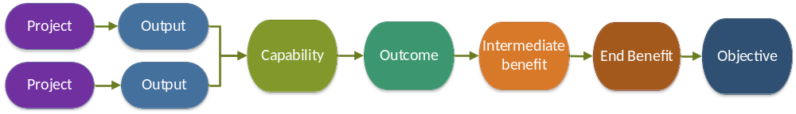

Emergent Benefits and Disbenefits
Unplanned benefits and disbenefits are likely to emerge during a programme.
Emergent benefits may be of a scale that provides a significant opportunity for the organisation and should be managed to ensure they are realised optimally. Or the benefits may have potential to make an impact at a local level and they should be encouraged, and their success should be celebrated.
Similarly, disbenefits should be recognised and managed to reduce risk to the programme.
It is the responsibility of the Benefits Realisation Manager, in partnership with business areas and project managers, to validate emergent benefits/disbenefits as robust and appropriate. In such situations, Benefits Profiles are developed for approval by the programme Steering Group.

Strathclyde Cloud Programme Benefits Realisation Map
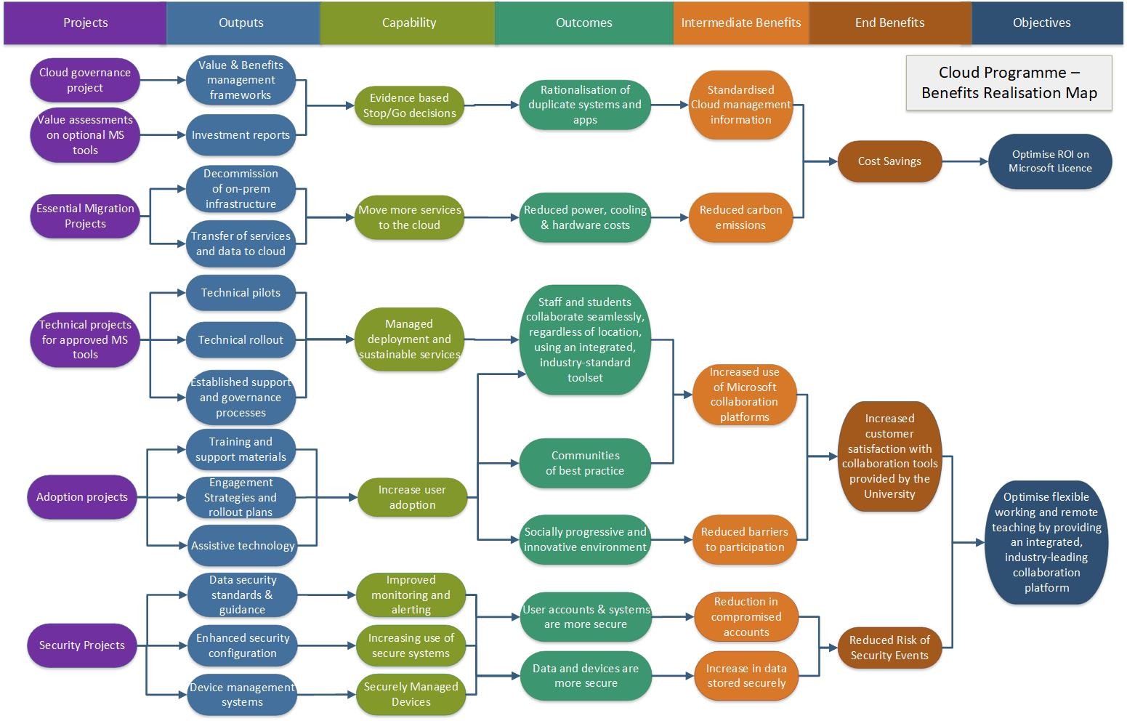

Governance Arrangements

Managing Benefits Throughout the Change Lifecycle
Business Case | Programme Initiation | Programme Delivery | Programme Close Down
Business Case Workshops:  - Objectives and high-level benefits identified.  Benefits Realisation Map:  - Based on outputs from the business case workshops,  - Refined via further consultation with key stakeholders.  Benefits Validated and Quantified:  - Key benefits are quantified for inclusion in the business case,  - Benefits are validated as robust and appropriate by the PMO,  - Key benefits targets are approved by the Executive Team.  Business Case Includes:  - Benefits Realisation Map,  - Performance targets. | Benefit Management Strategy:  - Outlines the Programme’s approach to benefits management.  - Approved by the SRO.  Benefits Risk Assessment:  - Risks to realisation of benefits identified during programme risk workshop and managed in programme risk register.  Benefit Profiles:  - Detailed description of benefit,  - Establishes baseline data,  - Defines measures, targets, and expected realisation schedule,  - Roles and responsibilities defined.  Benefit Register:  - Presents summary data from each Benefit Profile,  - Reports progress against expected realisation schedule.  - Benefit Profiles.  - Approved by the Steering Group. | Programme-Level Governance:  - Benefits Register reviewed by Steering Group,  - Emergent benefits, and dis-benefits, are identified throughout the programme. They are validated and worked into updated Benefits Profiles for approval by the Steering Group.  - End of tranche reviews include a review of progress against benefit register.  Project-Level Governance:  - As-is Baseline Reports provide performance baselines and identifies emergent benefits,  - The Exception Report process considers the impact of the change on benefits realisation,  - BAU responsibilities for benefits tracking are agreed as part of the service definition and/or project close-down,  - Lessons learned captured include lessons on benefits management. | Post-Programme Benefits Review:  - Review of forecast versus actual benefits realisation,  - Agree post-programme responsibilities for benefits tracking,  - Agree timescales for post-investment review,  - Gather benefits management lessons for future programmes,  - Include benefits review outcomes in the Post-Programme Review submitted to the Information Strategy Committee (ISC).  Post-Investment Review:  - Final review of forecasted benefits against actual realisation,  - Gather benefits management lessons for future programmes,  - Post-Investment Review submitted to ISC.

Benefits Management Documentation
Three key documents are used to track benefits realisation throughout the Programme: Benefits Realisation Map, Benefits Profile, and Benefits Register.

Benefits Realisation Map
Document | Benefits Realisation Map
Description | - A high-level map of the activity required to deliver the programme’s benefits and objectives.  - Developed iteratively for the business case, in partnership with key stakeholders.  - Once the programme has begun, any further changes are made by the Steering Group.
Purpose | - To facilitate agreement on the programme’s key objectives and the measurable benefits that support those objectives.  - The grouping of outputs drives the development of the programme’s project dossier.  - Provides a clear line of sight from projects to the end benefits and objectives.
Created | - During development of the business case.  - Approved by the Executive Team.
Updated | - Changes are unlikely post approval but can be approved by the Steering Group, following the Exception Process.

Benefits Profile
Document | Benefits Profile
Description | - A detailed description of each benefit, including baseline data, performance measures, targets, expected realisation schedule, and reporting responsibilities.
Purpose | - To provide a detailed definition for each benefit and a description of how it will be measured.  - Creates a common understanding of each benefit among stakeholders and reduces ambiguity.
Created | - Profiles for intermediate and end benefits are created during programme initiation stage.  - Profiles for emergent benefits and disbenefits are created during the programme, once validated as being robust and appropriate by the Benefits Realisation Manager.  - Approved by the SRO.
Updated | - As required, for example if a new performance measure is identified.  - Changes approved by Steering Group.

Benefits Register
Document | Benefits Register
Description | - Summarises key information contained within each Benefits Profile.  - Includes actuals and progress against expected realisation schedules.
Purpose | - To track realisation of benefits across the Programme.
Created | - During initiation.  - Approved by Steering Group
Updated | - A live document that is reviewed at each Steering Group meeting to assess whether benefits realisation is on track, or remedial action should be taken.

Benefits Management Roles and Responsibilities
Executive Team
- Approves benefits targets for the programme,
- Approves Benefits Realisation Map.
Senior Responsible Officer (SRO)
- Overall responsibility for ensuring the programme optimises the realisation of benefits,
- Approves Benefits Management Strategy,
- Approves Benefits Profiles.
Programme Steering Group
- Oversees progress of benefits realisation, via the Benefits Register and end of tranche benefit reviews, taking corrective action to optimise benefits realisation, if required.
- Approves Benefit Register.
Programme Manager
- Responsible for ensuring effective programme governance, including the implementation of the benefits management framework.
- Oversees the development of the Benefits Realisation Map, Benefits Management Strategy, Benefit Profiles and Benefits Register.
Benefits Realisation Manager
- Responsible for the development and delivery of the benefits management strategy, from identification through to realisation,
- Develops the Benefits Realisation Map, in partnership with the Programme Manager and business case development team.
- Develops the Benefits Management Strategy, Benefit Profiles and Benefits Register.
- Monitors delivery and identifies emergent benefits and disbenefits, in partnership with business areas and project managers.
- Responsible for monitoring dependencies and risks to realisation.
- Responsible for end of tranche, post-programme, and post-investment benefits reviews.

Version Control
Author:
Version | Date | Consulted: | Changes made:

