Benefits Management

Contents
1 About Benefits & Benefits Management 3
1.1 What is a Benefit? 3
1.2 What Types of Benefits are there? 3
1.3 What is Benefits Management? 4
1.4 What is Benefits Realisation? 5
2 The Relationship Between Projects and Benefits 6
2.1 Project Deliverables 6
2.2 The Project Lifecycle 7
3 Capturing & Tracking Benefits Information 8
4 THREE Points to Consider when managing benefits 9
5 Document management 10
Appendix A – Benefits Tracker Example(s) 11
Appendix B – Digital Strategy 2025 13
Appendix C - University Strategy 14

About Benefits & Benefits Management
The assumption that all projects should deliver some sort of benefit to the business might seem like common sense. However, effective capturing, measuring, monitoring, and realisation of business benefits, is activity that is often neglected when planning and delivering a project.

What is a Benefit?
The following is the definition of a benefit according to the Association of Project Management Book of Knowledge, which is provided by Axelos, the organisation behind the best practice frameworks for PRINCE2, MSP and ITIL:
“The measurable improvement resulting from an outcome perceived as an advantage by the investing organisation(s) and which contributes towards one or more organisational objectives”.
In its simplest terms, a benefit could be described as the “positive” result of a business change.
It is also possible to have a negative impact, or a “dis-benefit” associated with a business change. The Book of Knowledge defines this as:
“The measurable decline resulting from an outcome perceived as negative by the investing organisation(s) and which detracts from one or more organisational objectives”.
Benefits are the reason we invest in change initiatives (whether projects, programmes, or any other business improvement activities), and focusing on benefits can often require a cultural shift in terms of how we approach our justification for a change, and how we evidence its relative success.

What Types of Benefits are there?
At the highest level, benefits fit into two main types:
- Efficiency: Arising from outcomes that enable the organisation to create results with fewer resources resulting in cost reduction, cost avoidance or, reduced working capital. Essentially, doing more for the same, or the same for less.
- Effectiveness: Arising from outcomes that enable the organisation to create better results now or increase the likelihood of future effectiveness by improving adaptability achieving better quality results, or by increasing adaptability/flexibility.
To determine whether a benefit really is a benefit, a useful acronym, known as “MEDIC”, can be used:
- Maintain something useful (e.g., legislative compliance)
- Eliminate something unwanted (e.g., waiting times)
- Decrease something that is negative (e.g., processing costs)
- Increase something that is positive (e.g., productivity levels)
- Create something new (e.g., a new product or service)
When logging a benefit, you should stop and ask yourself whether it fits with one or more of the above. If it doesn’t, then what exactly is being delivered and why? Is it worth recording?

What is Benefits Management?
Benefits Management is defined as the identification, quantification, analysis, planning, tracking, realisation, and optimisation of benefits. It aims to ensure that benefits that have been identified at the start of a project are realised, and that any benefits that emerge as the project progresses are properly exploited. As many project benefits are not realised until after the project is closed it is important that appropriate structures are put in place to monitor benefits realisation post project.
For a benefit to be effectively managed, we would ideally be able to quantify it in some way (e.g., through the amount of revenue that will be generated, or the reduction in resources needed). We can therefore classify our ability to quantify benefits as illustrated in the table below:
Type | Description | Examples | Typical Measure
Financial | By applying a cost, price or other valid financial formula to a quantifiable benefit, a financial value can be calculated. | Increased Fees Revenue.  Reduced Supplier Costs. | + £120,000  - £65,000
Quantifiable | Sufficient evidence exists to forecast how much improvement / benefit should result from the change(s). | Increased Student Applications  Reduced processing times. | + 25%  - 10%
Measurable | Although this aspect of performance is currently being measured (or could be measured), it is not possible to estimate by how much performance will improve. | Increased space availability  Reduced number of meetings | Not Applicable
Observable | By use of agreed criteria, specific individuals or groups will decide to what extent the benefit(s) has been realised, based on their experience and judgement. | Increased satisfaction.  Reduced frustration  Risk avoidance | Not Applicable
It is also important for all benefits to have an owner, A Benefit Owner takes responsibility for a benefit or set of benefits associated with a project. They ensure that the benefits and the measures are put in place within the business area to ensure that they are realistic, avoid double counting and that these benefits continue to be realised once the project or programme has completed.

What is Benefits Realisation?
Benefits realisation is the execution of activity to deliver benefits, and the subsequent measurement of those benefits. It is delivered through a benefits realisation plan, which is a complete view of all the benefits, their dependencies, and the expected realisation timescales. However, to achieve the realisation of these benefits a transition plan will need to be in place. This is the transition from old to new ways of working and embedding the change in the operational business. This activity is usually led by operational area of the business impacted and would include activities such as:
- Preparing the business to implement the change while ensuring minimal disruption to BAU (Business As Usual) activity (e.g., through created of a robust Project Plan).
- Clearly identifying benefit owners (e.g., using a central Benefits Tracker)
- Establishing appropriate support (e.g., through FAQ’s, training guides, and sessions)
- Confirming that outputs are ready to use (i.e., through testing and sign off)
- Removing access to legacy practices and systems (e.g., by decommissioning old systems)
- Business change initiatives to support embedding the change (e.g., comms plans, feedback loops, business champions, and benefits monitoring)

The Relationship Between Projects and Benefits

Project Deliverables
Projects deliver outputs that provide some new or enhanced capability within the business (see Section 1.2 above). These capabilities are then transitioned into one or more outcomes that enable the realisation of benefits (value) that contribute to the achievement of strategic objectives.
Output | Capability | Outcome | Benefit
The deliverable from a planned activity (project). | A completed set of outputs (related projects and activities) that together provide the ability to deliver one or more outcomes. | A new operational state following a period of transition. | Improvement resulting from an outcome. Which is perceived by stakeholders, and/or contributes to strategic objectives.
The relationship between these concepts can be displayed as a Benefits Map, as shown in the example below:
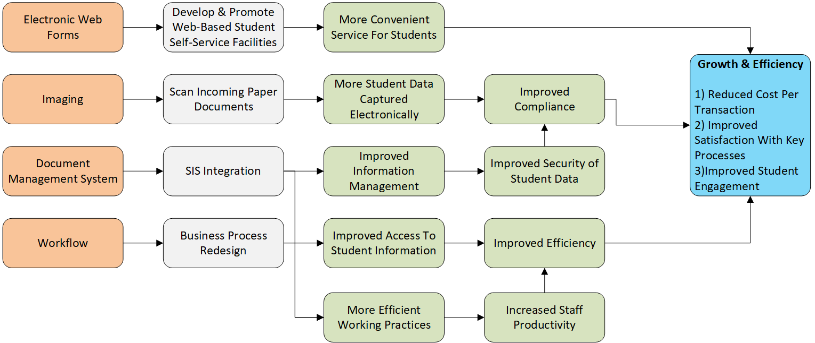

The Project Lifecycle
Benefits Management will occur throughout the project lifecycle as illustrated in the process flow below. Once identified, benefits will need to be captured and then monitored to ensure that they remain relevant. Should the project scope change, or some external factors come into play, they will need to be revisited and updated. As part of project closure, additional activity will be planned (which may be many months or even years in the future), to revisit the benefits, and re-baseline them to ensure that what was delivered met with the original expectations of the project. The following process diagram illustates where benefits activity fits within the Project Lifecycle.
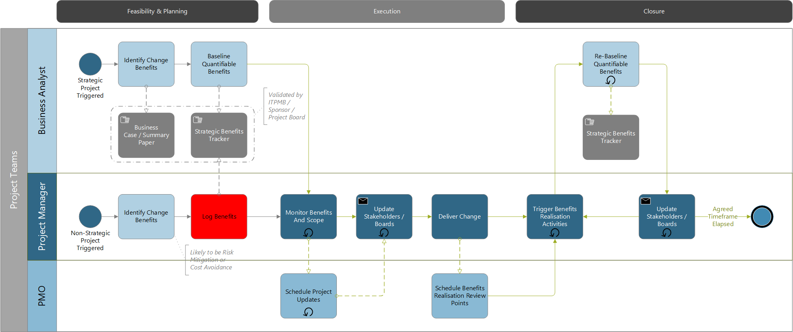
Further information on the project lifecyle can be found in the Project Lifecycle Guide.

Capturing & Tracking Benefits Information
Benefit profiling for any project or activity will be captured in the Business Case and Project Management Plan (PMP), which will then be collated/summarised centrally in the Benefits Tracker as part of the benefits realisation plan. The benefit profile should include the following:
- Strategic Aim: Which strategic aim does the benefit relate to? (see list)
- Strategic KPI: Which strategic KPI does the benefit support? (see list)
- Digital Strategy Categorisation: Which Digital Strategy classification does it relate to? (see list)
- Benefit Category & Type: What is the nature of the benefit? (see list)
- Any Risks or Dependencies: What factors might impact realisation of a benefit?
- Benefit Owner: A person or entity given authority to manage a particular benefit
- Benefit Description: What is the specific benefit?
- Benefit Delivery:
  - Delivery Confidence: How confident are we that the benefit will be realised
  - Measurement Approach: How can the benefit be measured?
  - Frequency of measurement: How often will the benefit be measured?
  - Realisation Time Frame: Over what time-period will the benefit be realised?
- Baseline Position
  - Baseline Date: The date at which the baseline measure was taken
  - Baseline Measure: The measure or indicator as-is position
- Projected Position
  - Date: The date by which the benefit will be fully realised
  - Measure: The measure or indicator to-be position
  - Savings: The savings expected (the difference between the as-is and to-be measures
  - Savings Type: Are the savings cash-based or opportunity-based?
  - Difference: The percentage difference between the as-is and to-be measures
  - Targets: Any performance targets or agreed budgets the benefit relates to 1
  - Dis-Benefits: Any negative impacts from the change 1
In terms of tracking, benefits will be reviewed on an ongoing process as part of the regular ITPMB updates. They will also be reviewed at project closure, and post-project via the PMO, which will track the documented review dates for benefits and obtain the results from the benefit owner to update the strategic benefits tracker where appropriate.
See Appendix A for an example of several completed benefits tracker entries.

Points to Consider when managing benefits
Benefits Management can be complicated, depending on the nature of the project, the benefit(s), and how easily they can be measured. The following is a list of key considerations when approaching benefits management.
- Understand how the Benefit will be Realised.
A key driver of benefits management is often the need to reduce costs. However, while some examples (e.g., moving to a cheaper supplier) can clearly result in cash savings, others (such as reduced staff processing times) can be more complicated. These types of benefit risk not being realised in a financial sense unless a clear plan is put into place to deliver them (e.g., by assigning staff elsewhere to revenue generating activities, or by staff restructuring/reduction. If not, then such benefits, although quantifiable, will not lead to cash savings. This often makes the difference between whether a benefit is Financial or Quantifiable in nature.
- Factoring in Resource to support Benefits Tracking & Realisation
It is not uncommon for considerable time to be spent on capturing and baselining benefits as part of a project. However, there is often insufficient time factored into later stages of the project (and post-project) to ensure that benefits continue to be tracked, and evidence provided to prove that benefits realisation has occurred. It is essential that resource is protected to support relevant activities, not just during the project, but sometimes for months or years afterwards.
- Don’t confuse Outcomes with Benefits
The benefit of a project is not an outcome that is delivered, it is how the outcome is used that will provide the benefit. For example, delivering a coffee machine is not a benefit, the outcome of being able to buy coffee is not a benefit, improving productivity by reducing the need for staff to go off-campus (and waste time) IS a benefit. When identifying benefits, keep asking yourself, “what does this give us?” until you reach the logical (benefits based) conclusion. If you find yourself going round in circles, describing only outcomes, then in all likelihood you have not identified a benefit.
- Lack of or poor quality data and information
In the absence of detailed information, for example a system to obtain data from or detailed process maps baselining process improvements may often rely on workshops or observation to understand the AS-IS situation and must make assumptions around the improvements the TO-BE will bring. These estimates can vary and are difficult to verify. This means that confidence levels for improvements should always be applied with regular reviews of the expected benefits to be realised during the lifecycle of a project to validate these initial estimates or assumptions as actual evidence and information becomes available.

Appendix A – Benefits Tracker Example(s)
The following tables provide typical examples of benefits capture based on an actual live project.
Financial & Quantifiable Benefits
Project Profile
Project | Status | Date Delivered
Curriculum Management | Live | ETA 08/2022
Curriculum Management | Live | ETA 08/2022

Benefit Profile
Strategic Aim | Strategic KPI |  | Benefit Category
Growth and Efficiency | Reduced cost per transaction and improved user satisfaction |  | Quantifiable
Growth and Efficiency | Reduced cost per transaction and improved user satisfaction |  | Quantifiable

Benefit Type | Benefit Owner | Benefit Description
Increased Efficiency - Process | A N Other | Curriculum Processing will be reduced, freeing up staff time.
Increased Efficiency - Process | A N Other | The number of loss-making Courses introduced will be reduced, freeing up staff time.

Benefit Delivery
Delivery Confidence | Measurement Approach | Frequency of Measurement | Realisation Timeframe
High | Metrics Analysis | Annually | 1-2 Years
Moderate | Metrics Analysis | Annually | 1-2 Years

Baseline Position |  | Projected Position
Date | Measure | Date | Measure | Savings (p.a.) | Difference | Relates to Existing Target/Budget?
2020 | £735,555.36 | 2023 | £576,065.36 | £159,490 | -21.68% | No
2020 | £154,544.05 | 2023 | £77,272.05 | £77,272 | -50.00% | No

Measurable & Observable Benefits
Project Profile
Project | Status | Date Delivered
Curriculum Management | Live | ETA 08/2022
Curriculum Management | Live | ETA 08/2022

Benefit Profile
Strategic Aim | Strategic KPI
People First | University to be in the QoWL sector upper quartile measure for engagement and satisfaction
People First | University to be in the QoWL sector upper quartile measure for engagement and satisfaction

Benefit Profile
Benefit Category | Benefit Type | Benefit Owner | Benefit Description
Measurable | Increased Satisfaction - Staff | A N Other | Improved access to curriculum information leads to increased staff satisfaction.
Observable | Reduced Frustration - Staff | A N Other | Reduced duplication of effort, rekeying of data, and data errors reduces staff frustration.

Benefit Delivery |  |  | Baseline Position
Delivery Confidence | Date | Details | Measurement Approach | Frequency of Measurement | Realisation Timeframe
Moderate | 2021 | Satisfaction with the CM processes averaged at 58% | Survey | Annually | 1-2 Years
Moderate | 2021 | Users felt frustrated at times with the volume of re-keying and lack of data reuse. | Informal Feedback | Annually | 1-2 Years

To be recorded in the PMP, Business Case, and associated registers (not the Tracker)
When taking into consideration any dependencies or external factors that might impact the project

