UCISA Benefits Group

Project Level Artefacts

Note: Templates should be created to reflect the particular organisation’s practices

Benefits Management Strategy

According to APMG, typical contents include:
- Scope and explanation of which areas of the business will be covered by benefits management and realisation activity
- Measurement methods and processes that will be used to monitor and assess the realisation of the benefits (including the level of granularity to be applied to the Benefits Realisation Plan)
- A description of the functions, roles, accountabilities and responsibilities for benefit planning and realisation, aligned with the programme’s organisational structure
- Priorities for the project in terms of benefit types to be sought (for example financial – cashable) to inform the filtering and prioritisation process
- Processes to ensure that benefits are not double counted and that cumulative benefits are achievable
- The relationships between capabilities and the benefits
- Clarity, if necessary, as to opportunities to be managed in relationship to benefit risk management
- The relationship with other project information
- Categories to be used by the project or inherited from a programme or portfolio
- Any organisational-specific information or headings that should be included in the benefit profiles
- Tools, systems and sources of information that be used to enable measurement
- Critical success factors against which the effectiveness of benefits management should be measured
- Clarification of benefits-related terminology appropriate to the organisation
- The review and assessment process for measuring benefits realisation, covering who will be involved in the reviews, and how and when the reviews will be carried out
- Standards for identifying, mapping, monitoring and reviewing the project’s benefits

Benefits Realisation Plan

According to APMG, typical contents include:
- A schedule detailing when each benefit, dis-benefit or group of benefits will be realised (typically as a chart)
- Appropriate milestones for benefit reviews to take a forward view of the likelihood of ongoing success
- Estimated effort and costs associated with the plan
- Details of transition schedules
- Benefit reporting schedule, which is submitted to the EPB
- Relationship between outcomes and benefits in the schedule (typically connector lines)
- Dates when specific outcomes that enable the benefits will be achieved
- Dependencies external to the project
- Details of any handover and embedding activities, beyond the mere implementation of a deliverable or output (business change), to enhance the process of benefits realisation after the capability has been delivered; this part of the Benefits Realisation Plan is also referred to as the transition plan
- Benefit Maps

Benefit Maps

Here is an example of a benefits map produced in Amplify

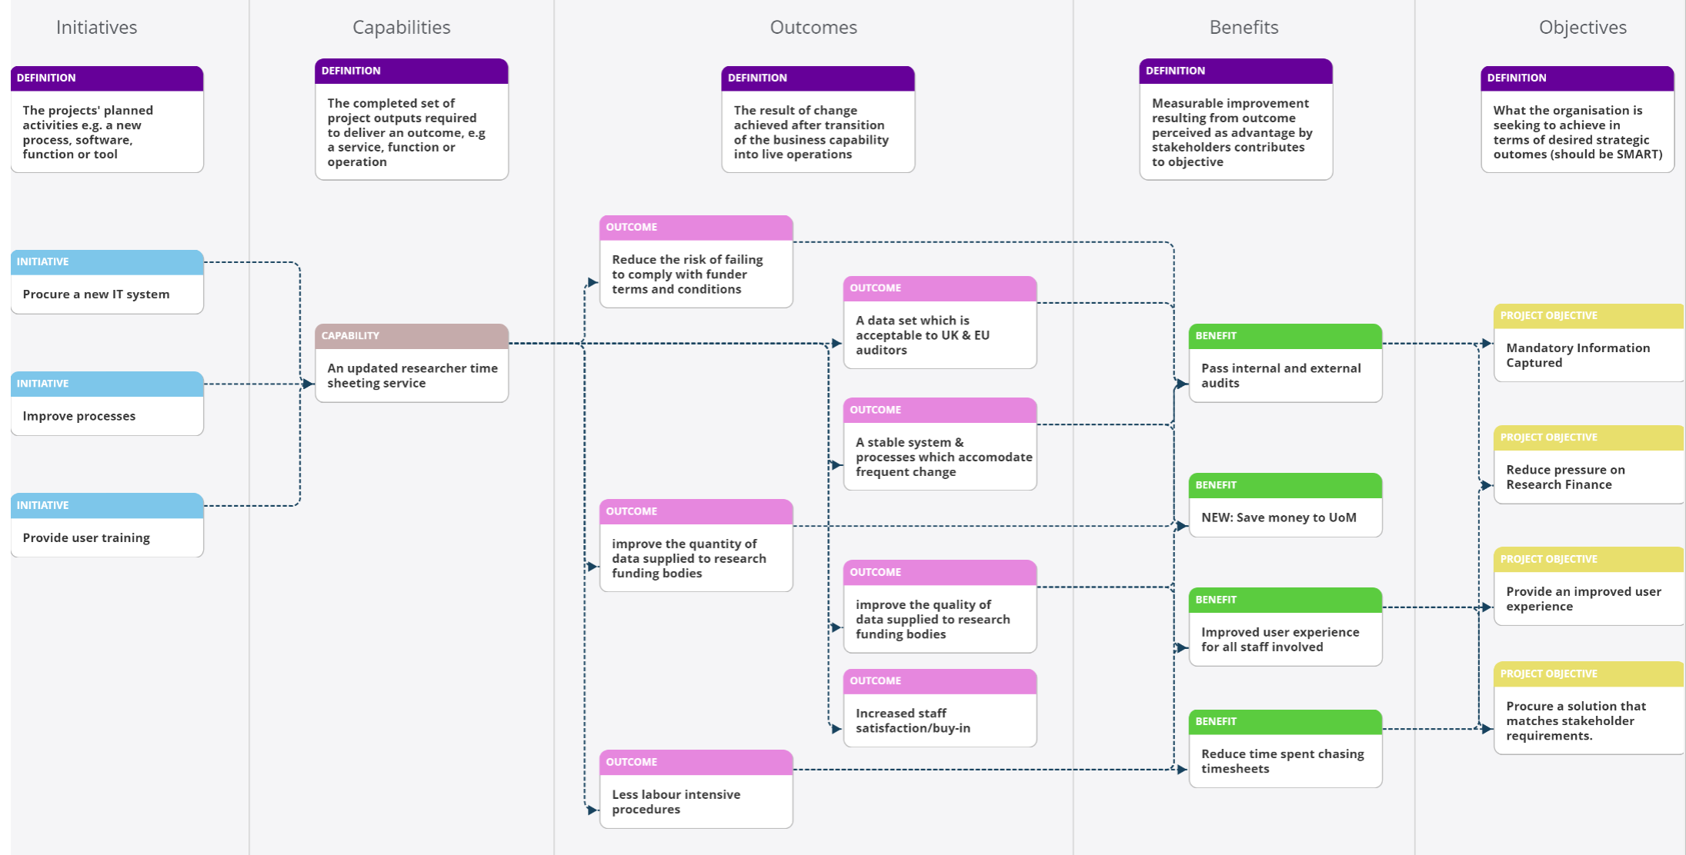

Benefit Profile

According to APMG, typical contents include:
- Reference number or identifier
- Description of the benefit (or dis-benefit)
- Organisational objectives supported
- Category or categories that are appropriate to the benefit
- Business KPIs that will be affected by the benefit
- Current or baseline measures and anticipated improvement
- Business realisation and business change costs
- Capabilities required for the benefit to be realised (see benefits map)
- Outcomes that will be need to be in place for the benefit to be realised (see benefits map)
- Business changes required for realisation (to process, culture, people, policy, often called change elements)
- Related issues and risks that pertain to the benefit
- Any internal or external (to project) dependencies
- Who is responsible for realising this benefit?
- Attribution: the benefit owner and business area that will receive this benefit
- Measurement
Example
BENEFIT PROFILE TEMPLATE
ID | Unique | Owner | Named individual
Profile sign off date | Date | Profile Last Reviewed | Date
Benefit Overview |  | High-level description – link to org goal
Detailed Description
Describe the main attributes of the benefit and its relationship with other benefit and the eventual outcomes (e.g. as enable@ intermediate or end benefit)
Actions Taken:
List outcomes of benefit reviews taken with dates and reasons
Stakeholders | Individuals or groups impacted by the benefit
Benefits Valuation | Whether tangible/financials
Key Assumptions | Show assumptions about probability or value of benefit
Risks to Benefit | List specific risk or link to benefit risk register
Costs | Costs associated with measurement or realisation
Performance Measure | KPIs now or in the future, if not capable of direct measurement, what trend analysis or other test can be used to track achievement?
Target Performance | Expected performance at each milestone in realisation plan and ‘end state’ performance
Measurement Source | System or information source(s) required for measurement
Measurement Roles | Information system owners
Dependencies | Cross-reference other projects benefits by unique ID and/or list external dependencies (environmental, other projects, technical etc.)

